IT Infrastructure Task 4 NFS Accounts and Intrusion Detection
This report documents NFS sharing, departmental access controls, and Snort rule configuration and testing.

NFS

Task 1: Install NFS on Ubuntu Server
Install nfs kernel server to run nfs for the server
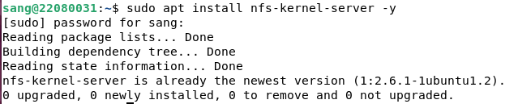
The server installs nfs-kernel-server, which provides the NFS service used to export directories. The package manager reports that it is already installed in this VM.
Check server’s IP address which is 192.168.56.118
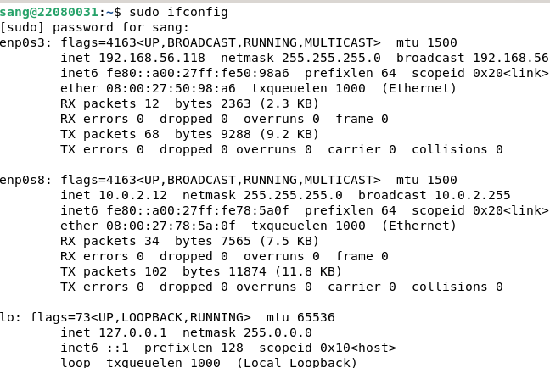
The interface listing shows the server at 192.168.56.118 on the lab network. The client uses this address as the source of both NFS mounts later in the exercise.
Enable and start the service
The service commands enable NFS at boot and start it for the current session. The server is ready to publish shares after /etc/exports is configured.

Task 2: Install NFS Client on the Linux Client
Check client’s IP address which is 192.168.56.113
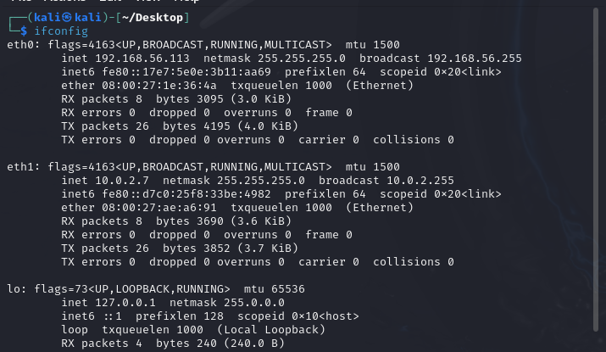
The client screenshot shows 192.168.56.113 on the same /24 network as the NFS server. The pictured client is Kali Linux, despite the section heading calling it an Ubuntu client.
Update the system
The client refreshes its package lists before installing NFS utilities. This allows apt to use the repositories configured on the client system.
Install nfs common to run nfs on the client
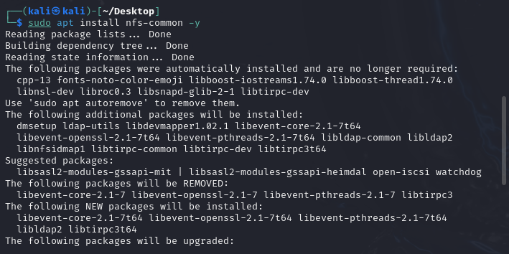
The nfs-common package supplies client-side NFS tools, including support for the mount commands used below. The screenshot shows the install being requested on the Kali client.

Task 3: Create Directories on Server
Make directory for mounting public for everyone can access, and private for limited client access
The server creates separate public and private directories under /mnt/nfs. These paths become the export roots named in /etc/exports.
The chmod commands set the public directory to 755 and the private directory to 777. Mode 777 gives every local user read, write, and execute permission, so the private name does not by itself make that directory private on the server.
Change permission for 2 directories according to the following:
The permission table translates those modes into owner, group, and other access. Public is writable only by its owner; private is writable by everyone locally, and its network access relies on the export rule.

Task 4: Configure exports file on Server
Access the export file to define which directories on the server are shared with NFS clients and specify the access permissions for each one.
The server opens /etc/exports, the file that controls which paths NFS clients may mount. Each line combines a local directory, an allowed client set, and mount options.
The following table explain the configuration:
The public export uses * to allow any client that can reach the server, while the private export names only 192.168.56.113. Both entries allow read and write access and use sync and no_subtree_check.
The export table explains that * is broad access and the single client address restricts who can mount the second share. Export restrictions do not replace local filesystem permissions or a network firewall.
allow export all directories listed in the above configuration, then restart the service.
exportfs -a applies the listed exports, and the NFS service is restarted. These actions make the updated /etc/exports settings available to client mount requests.

Task 5: Mount NFS Directories on the Client Side
Stop the firewall service
The server's UFW service is stopped before testing NFS. This removes a firewall obstacle in the lab, but it also removes the server's firewall protection; a deployed system should permit the required NFS traffic explicitly.
Create the public and private directory in the client
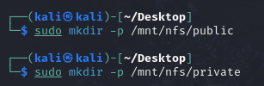
The client creates matching local mount-point directories. These empty paths will display the server's files once the remote shares are mounted.
Now mount client’s public and private with server’s public and private respectively
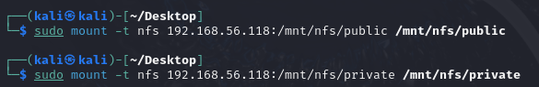
The two mount commands connect the client paths to the server's public and private exports at 192.168.56.118. A successful mount makes remote files appear under /mnt/nfs on the client.

Task 6: Create a File with HAN Number in Private Directory
writes 22080031 into 22080031.txt inside the /mnt/nfs/private/
The client writes the student number into a file inside the mounted private share. Because the path is mounted over NFS, the file is written to the server's exported directory.

Task 7: Access the File from the Server
Go to the server and verify by displaying the file in private folder and displaying the content of that file
The server lists the new file and reads its contents, confirming that the client write reached the NFS export. The displayed nobody/nogroup ownership is consistent with an unmapped or squashed remote identity in this lab.

Account management (AM)

Task 1: Users and groups creations
Create 8 users from 1 to 8
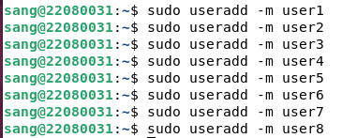
Eight local user accounts are created with home directories. These accounts provide test identities for the departmental group and permission exercise.
Set password for each user from 1 to 8
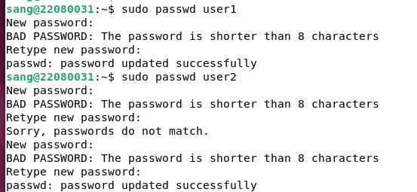
The password commands assign credentials to the new accounts. The screenshot includes short-password warnings, so successful account creation should not be taken as proof of strong password policy.
Print the /etc/passwd file to verify the number of user
The first /etc/passwd capture shows the newly added user entries. This file records account names and IDs, but it does not reveal their passwords.
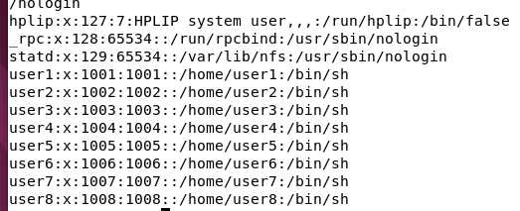
The continuation of /etc/passwd shows user1 through user8. Together with the first capture, it verifies that all eight test accounts exist.
There are exactly 8 users that we print above
Add 4 groups for 4 departments: IT, HR, Marketing and Finance
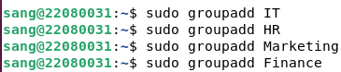
Four groups are created for IT, HR, Marketing, and Finance. Groups provide a common identity for setting directory access by department.
The usermod commands add each account to its assigned department group. The distribution is one IT user, one HR user, three Marketing users, and three Finance users.
Append user to the correct group according to the below table:
The accompanying table summarizes the intended user-to-group assignment. It is the reference used to check the later getent output.

Task 2: Directories creations
Make directory for each group:
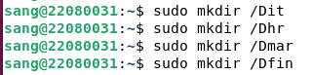
Four top-level directories are created, one per department. Each path will receive group ownership and access rules matching the assignment table.
Change the group ownership of the directory. Each group will be the owner of its directory
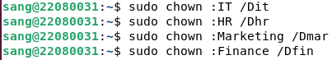
The chown commands set each directory's group owner to its department. Group ownership lets a single mode or ACL entry apply to all members of that department.
Then set full read, write and execute for user and group user. But other don’t have any permission
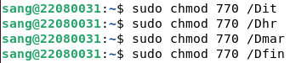
The chmod 770 commands give the owner and owning group full access and deny access to others. The later ACLs add selected cross-department exceptions to this base rule.

Task 3: Users and groups permissions
The setfacl commands grant IT access to every department and HR access to HR, Marketing, and Finance, while denying Marketing and Finance access to other departments. ACLs add these named-group rules on top of the standard owner/group/other bits.
The command sets Access Control Lists. -m modifies permissions, and g:GROUP targets a group for the specified directory. Therefore, the command set the access privileges like in the following:
The access matrix summarizes the intended result: IT can enter every directory, HR can enter three, and Marketing and Finance are limited to their own. It should be read alongside the actual ACL settings, because a matrix alone does not enforce permissions.
visudo is opened to edit sudo policy safely. This is separate from filesystem access: a user may be able to enter a directory without being allowed to run administrative commands.
Edit visudo, which controls sudo privileges for users and groups, then edit as the following configuration:
The sudoers screenshot gives HR broad sudo rights and adds narrow /bin/false entries for Marketing and Finance. Those entries do not grant useful administrative actions, but they should not be described as a general deny rule if other sudoers entries also apply.
The explanation table interprets the sudoers entries. HR can run commands through sudo after authentication, while the other shown entries permit only the no-op /bin/false command.
Now verify our configuration by the following ways
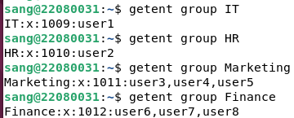
getent group lists the current membership of all four department groups. The output matches the user assignments made earlier in the exercise.
Use getent check all the user in existing groups
Then check the access permission of each directory
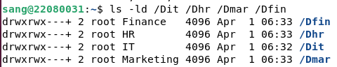
The ls -ld output shows each directory's group owner and a trailing + on its permission string. The + indicates that extended ACL entries are present in addition to the basic 770 mode.
Finally, switch to a user in the list and try to access every directory to check the privilege
The user3 test fails to enter /Dit but succeeds in /Dmar. Because user3 belongs to Marketing, this is a concrete check of the intended access boundary.

Intrusion Detection

Task 1: Install Snort on Ubuntu Server
Install snort for intrusion detection system
The package manager installs Snort and its supporting rule packages. Snort is an intrusion detection engine that can inspect traffic and write alerts for matching rules.
Check IP address which is 192.168.232.132
The server interface output gives 192.168.232.132 on ens33. This is a different lab network from the earlier 192.168.56.x NFS exercise, and the following Snort tests use this address.
Then enter the IP address as a sniffing address.
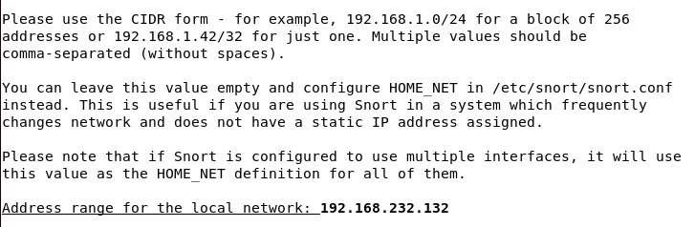
The installer asks for the local network value used by Snort's default configuration. The screenshot enters the server address; that protects a single host unless the setting is changed to the full subnet.

Task 2: Configure “snort.conf” file
Firstly, backup the configuration file
The existing snort.conf is copied to a backup before editing. Keeping the original makes it possible to compare or restore the configuration if a later change fails validation.
The main Snort configuration file is opened. This file defines network variables, rule locations, included rules, and inspection behavior.
After that, configure snort with the following code:
The paired configuration captures set HOME_NET to 192.168.232.132 and EXTERNAL_NET to addresses outside it. With a single-host HOME_NET, rules using these variables focus on traffic to or from this server rather than the entire /24 network. The rule-path settings tell Snort where to find local, shared-object, and preprocessor rules. Correct paths are required for the later include statement to load the custom alerts.
The local.rules include makes the five custom rules part of the Snort configuration. Without this line, editing the local rule file would not cause Snort to evaluate those rules.
The configuration table explains the network and rule-path variables. It connects each setting to the traffic scope or file location used when Snort starts.
Then start, enable and check the service status
The service status shows Snort active after it is started and enabled. The initial systemctl enable attempt failed, but the subsequent command succeeded through the service's SysV integration.
Validates the Snort configuration with:
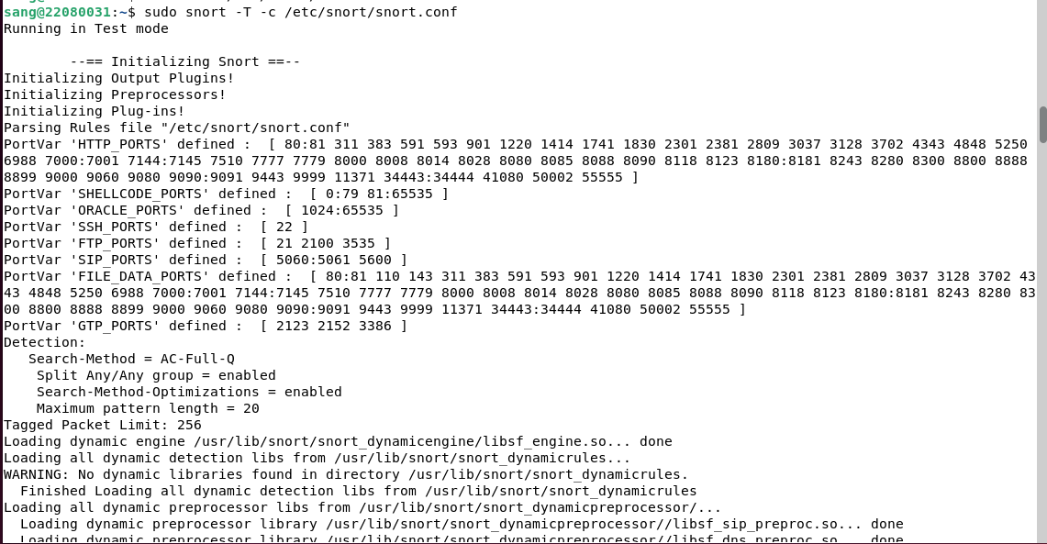
The snort -T command loads the configuration in test mode. It checks whether Snort can parse the options and rules without running a live packet test.
The test output ends with a successful validation message. That confirms the configuration can load, but it does not establish that every custom rule will trigger as intended.
The local.rules file is opened for custom alert definitions. Each rule needs a protocol, traffic direction, match conditions, message, and unique Snort ID.
Now, configure the snort detection rule in the /etc/snort/rules/local.rules with the following code:
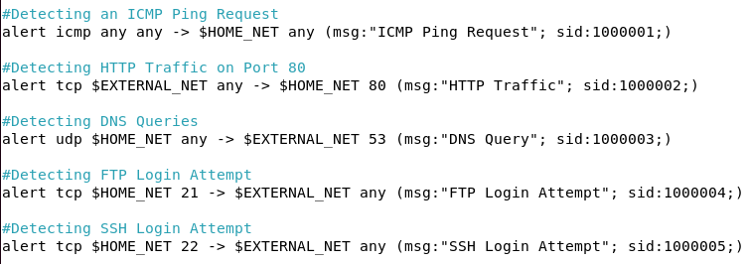
The five shown rules match ICMP ping, HTTP traffic, DNS queries, and packets involving FTP or SSH ports. The last two are port-based indicators; they do not by themselves prove that a user actually logged in.
Rule explaination:
The rule table summarizes protocol, direction, port, alert text, and SID for the five custom rules. It is a compact reference for interpreting later alert log entries.
Then restart the service
Snort is restarted so it loads the edited local.rules file. A restart is necessary because the running process does not automatically use changes written to disk.

Task 3: Create Five Rules and Test the ICMP Rule
Check client’s IP address which is 192.168.232.128
The client interface output identifies 192.168.232.128 as the test source. It shares the 192.168.232.0/24 network with the Snort server.
Then ping the server
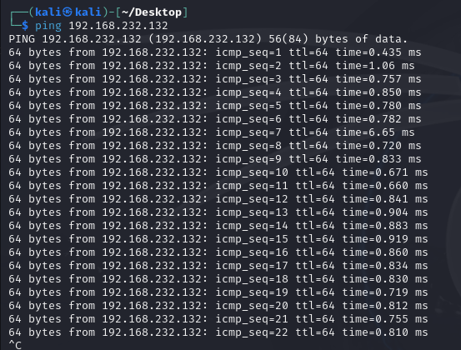
The client sends repeated ICMP echo requests to 192.168.232.132 and receives replies. This supplies traffic for the custom ping rule while also showing basic reachability.
Go back to the server and check alert log
The general alert log contains Snort entries, including other scan and traffic alerts. It shows that the daemon is writing events, but those entries need to be matched to a rule ID before interpreting a specific test.
The ping alert are shown with the correct client IP (192.168.232.128)
The final alert capture shows SID 1000001 with source 192.168.232.128 and destination 192.168.232.132. This verifies the custom ICMP rule for the ping test; the document does not show comparable tests for the other four custom rules.

